**PITCH FOLLOWER**

**USING**

**The tone() function**

This example shows how to use the tone() command to generate a pitch that follows the values of an analog input

**Hardware Required:**

* 8-ohm speaker
* 1 photocell
* 4.7K ohm resistor
* 100 ohm resistor
* breadboard
* hook up wire

**Circuit:**

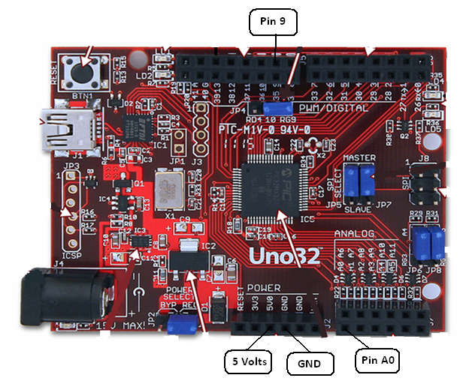

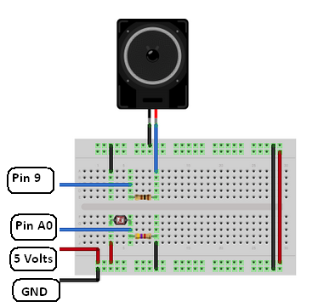

Connect one terminal of your speaker to digital pin 9 through a 100 ohm resistor, and its other terminal to ground. Power your photoresistor with 5V, and connect it to analog 0 with the addition of a 4.7K resistor to ground.

**Code:**

The code for this example is very simple. Just take an analog input and map its values to a range of audible pitches. Humans can hear from 20 - 20,000Hz, but 100 - 1000 usually works pretty well for this sketch.

You'll need to get the actual range of your analog input for the mapping. In the circuit shown, the analog input value ranged from about 400 to about 1000. Change the values in the map() comand to match the range for your sensor.

The sketch is as follows:

*/*  
  Pitch follower  
   
 Plays a pitch that changes based on a changing analog input  
   
 circuit:  
 * 8-ohm speaker on digital pin 8  
 * photoresistor on analog 0 to 5V  
 * 4.7K resistor on analog 0 to ground  
  */*  
  
  
void **setup**() {  
  *// initialize serial communications (for debugging only):*  
  Serial.begin(9600);  
}  
  
void **loop**() {  
  *// read the sensor:*  
  int sensorReading = analogRead(A0);  
  *// print the sensor reading so you know its range*  
  Serial.println(sensorReading);  
  *// map the pitch to the range of the analog input.*  
  *// change the minimum and maximum input numbers below*  
  *// depending on the range your sensor's giving:*  
  int thisPitch = map(sensorReading, 400, 1000, 100, 1000);  
  
  *// play the pitch:*  
  tone(9, thisPitch, 10);  
  
}